**RWOMUHORO SECONDARY SCHOOL**





**P.O.BOX 293, IBANDA**

**Email:** [**rwomuhoro.secschool@gmail.com**](mailto:rwomuhoro.secschool@gmail.com)

**0772 874 817/ 0782 272 702/ 0774 349 639/0782721790 /0777841156**

**ADMISSION FORM 2024**

This is to confirm that ……………………………………………………………………………………… has been offered a study vacancy in Senior………… to offer ……………. combination for “A” level. He/ she should report on ……………………………………. for lessons.

**SCHOOL FEES STRUCTURE**

**DAY STUDENTS**

|  |  |  |  |  |  |  |
| --- | --- | --- | --- | --- | --- | --- |
|  | **S.1** | **S.2** | **S.3** | **S.4** | **S.5** | **S.6** |
| Tuition fees (Termly) | 180,000= | 220,000= | 220,000= | 400,000= | 280,000= | 400,000= |
| Id & passport photos (once) | 15,000= | 15,000= | 15,000= | 15,000= | 15,000= | 15,000= |
| Report book (once) | 5,000= | 5,000= | 5,000= | 5,000= | 5,000= | 5,000= |
| School badge (once) | 2,000= | 2,000= | 2,000= | 2,000= | 2,000= | 2,000= |
| Learning projects | 5,000= | 5,000= | 5,000= | 5000= |  |  |
| SESEMAT fee (Termly) | 1,000= | 1,000= | 1,000= | 1,000= | 1,000= | 1,000= |
| ROSA (termly) | 1,000= | 1,000= | 1,000= | 1,000= | 1,000= | 1,000= |
| ASSHU | 2,000= | 2,000= | 2,000= | 2,000= | 2,000= | 2,000= |
| **TOTAL** | **211,000=** | **251,000=** | **251,000=** | **431,000=** | **306,000=** | **426,000=** |

**BOARDING STUDENTS**

|  |  |  |  |  |  |  |
| --- | --- | --- | --- | --- | --- | --- |
|  | **S.1** | **S.2** | **S.3** | **S.4** | **S.5** | **S.6** |
| Tuition fees (Termly) | 300,000= | 350,000= | 350,000= | 450,000= | 360,000= | 450,000= |
| Hair shaving fee (Termly) | 4,000= | 4,000= | 4,000= | 4,000= | 4,000= | 4,000= |
| Id & passport photos(once) | 15,000= | 15,000= | 15,000= | 15,000= | 15,000= | 15,000= |
| Report book (once) | 5,000= | 5,000= | 5,000= | 5,000= | 5,000= | 5,000= |
| School badge (once) | 2,000= | 2,000= | 2,000= | 2,000= | 2,000= | 2,000= |
| Learning projects | 5,000= | 5,000= | 5,000= | 5000= |  |  |
| SESEMAT fee (termly) | 1,000= | 1,000= | 1,000= | 1,000= | 1,000= | 1,000= |
| ROSA (termly) | 1,000= | 1,000= | 1,000= | 1,000= | 1,000= | 1,000= |
| ASSHU | 2,000= | 2,000= | 2,000= | 2,000= | 2,000= | 2,000= |
| **TOTAL** | **335,000=** | **385,000=** | **385,000=** | **485,000=** | **390,000=** | **480,000=** |

**NOTE:** S.4 & S.6 Students will pay **UNEB registration** fees next term as follows;

S.4 students ………………. 164,000=

S.6 students ………………. 186,000=

* S.3, 4, 5 & 6 Students offering Art will pay Shs 20,000= to buy art materials and tools.

**STATIONERY**

S.1 – S.2 One ream of ruled papers

S.3 - S.6 One ream of Dolphin or Rota trim for computer (plain) papers

A text book in a combination (a real book for A’ level) and a Mathematics text book (NCDC) for O’level.

**OTHERS (SANITATION & HYGIENE)**

S.1 – S.6 One slasher, 2 brooms, Toilet papers; 4 rolls (day students) and 6 rolls for boarders.

**BOARDING STUDENTS’ NECESSITIES**

A mattress, blanket, bed sheets, a pillow, a plate, a cup, a fork, a basin, 10 litres Jerrycan, at least 3 packets of sanitary pads for girls and six knickers, flash torch with at least 2 pairs of dry cells, personal jerry or Vaseline, towel, slippers, and all necessary scholastic materials especially exercise books, pens, pencils, art books, graph books, calculator, mathematical set and other personal belongings.

**DAY SCHOLARS: MUST** come with a plate and a fork. “A” level at least 2 black skirts / 2 pairs of trousers with at least 2 long sleeved white shirts/ blouses and a black sweater.

“O” level at least 2 navy blue skirts, 2 pairs of trousers with at least 2 short sleeved white shirts/ blouses and a navy blue sweater.

**NOTE:** T-shirts are available at school; white T-shirts can be worn in classes while blue and red T-shirts are for casual wear for boys and girls respectively.

Also black belts, a pair of black closed shoes are required. Grey stockings for boys and white for girls are also needed.

**UNIFORM CHARGES**

|  |  |
| --- | --- |
| A skirt for both “O” and “A” Levels | 20,000= |
| A pair of trousers for “O” and “A” levels | 25,000= |
| A shirt/blouse for “A” level | 20,000= |
| A shirt/blouse for “O” level | 16,000= |
| A collarless T- shirt | 15,000= |
| A T- shirt with a collar | 25,000= |
| A school sweater | 25,000= |
| A uniform neck tie | 7,000= |
| Sports wear | 15,000= |

* **Casual wear;** Girls should bring black long Caribbean skirts which are not tight, without slits and below the knees. Boys should bring a black trouser with a turn up of 15 inches.

**School dues** can be through **school pay** using your child’s payment code, to the Bank on school account number **5210600085 Centenary Bank Ibanda branch** in the names of Rwomuhoro s s with charges of 3000= per deposit or to **RWOSSIS SACCO** Ltd in Rwomuhoro trading centre Account number **0009** with charges of 3,000= per deposit.Visiting day will be on Saturday 2nd March, 2023.

Yours

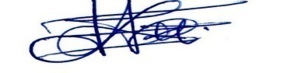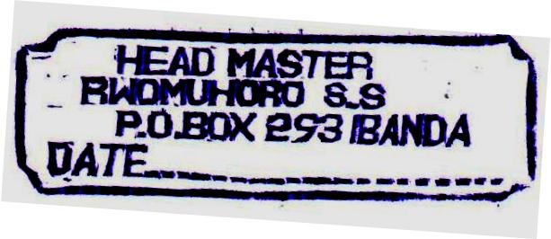

**MUHUMUZA HAMSON (HEAD TEACHER) 0777 841 156/0754 362 378**